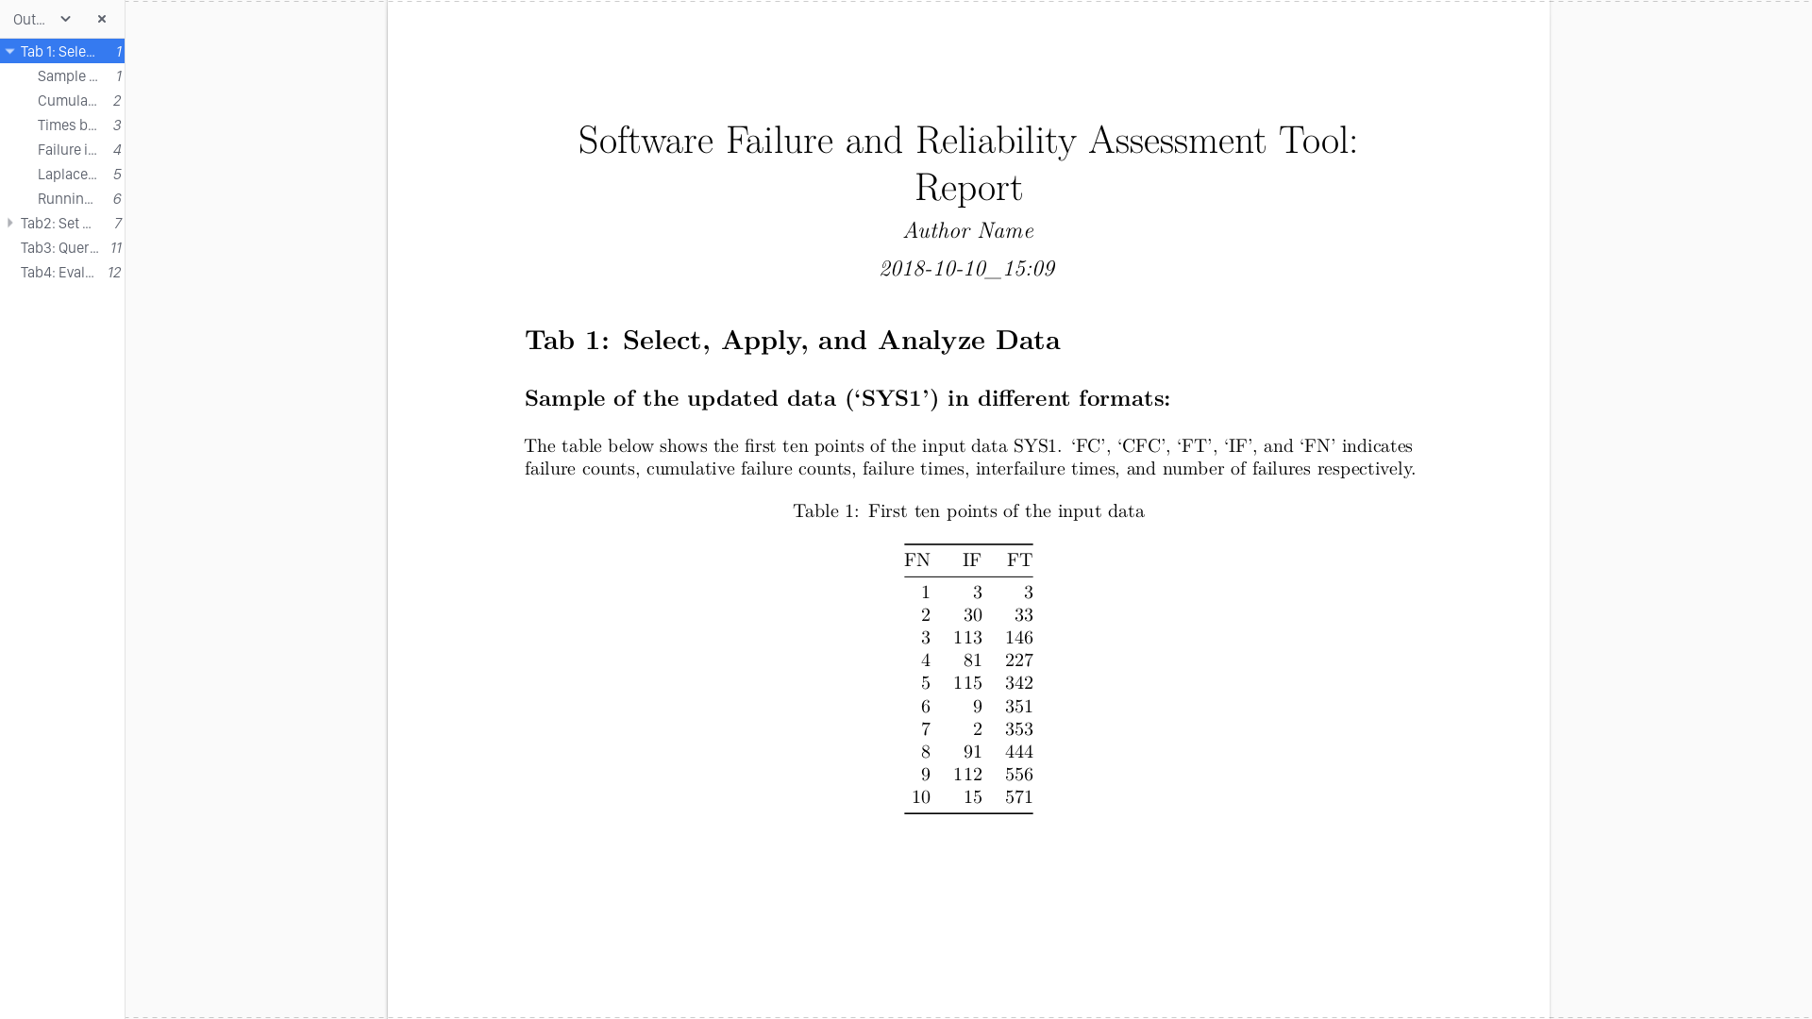

Figure _: Verbose Assessment Report

A run of the script shows a sample of the SYS1 model data set. This run demonstrates the ability of the tool to sample the data in different formats. After the user is prompted to select between a verbose report and a non-verbose report, selecting “1” will generate a report with descriptions of each display or graph.

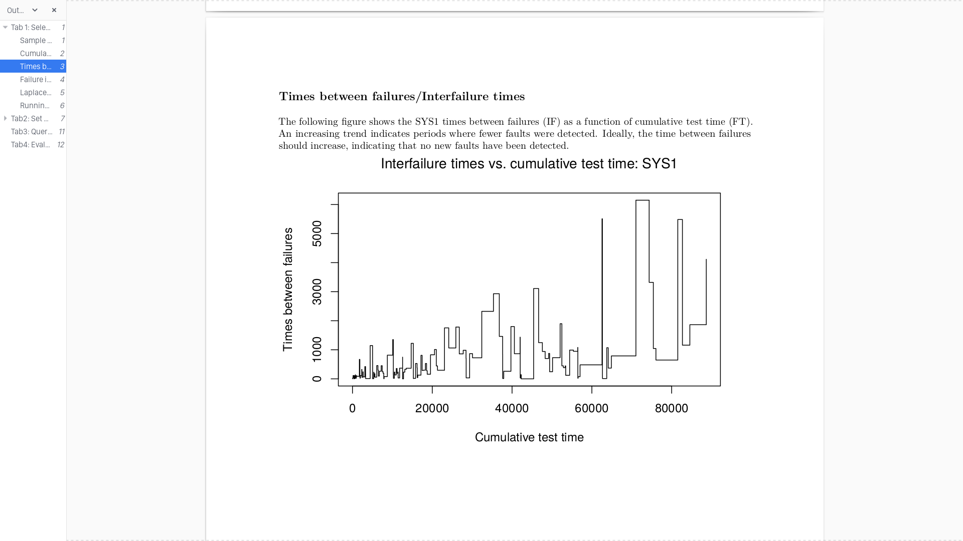

Figure _: Verbose Assessment Report 2

The generated report includes graphs that give users a visual assessment of the correlation between cumulative test times and the time between recorded failures. These visual aids assist users in visualizing data trends during their research.

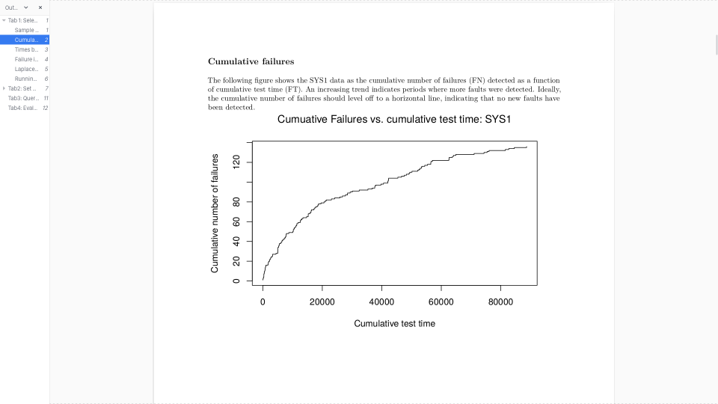

Figure _: Verbose Assessment Report

The report demonstrates cumulative number of failures as a function of cumulative test time, allowing users to identify where the trend will level off into a horizontal line, indicating a drop in failures over time.

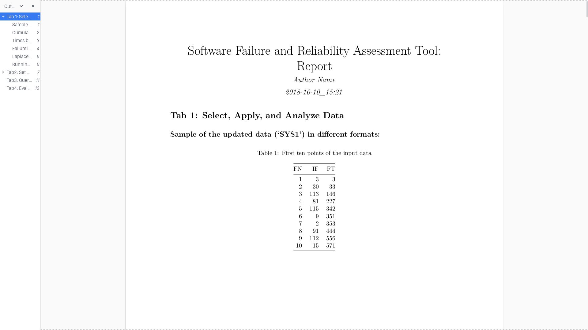

Figure _: Non-verbose Report Generation

This report generates a graph of time between failures as a function of cumulative test times sans description for users to interpret.

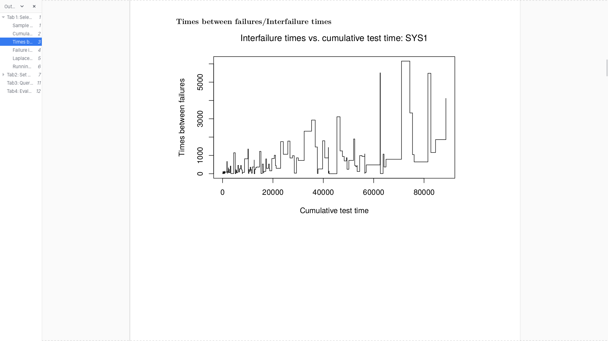

Figure _: Non-verbose Report Generation 2

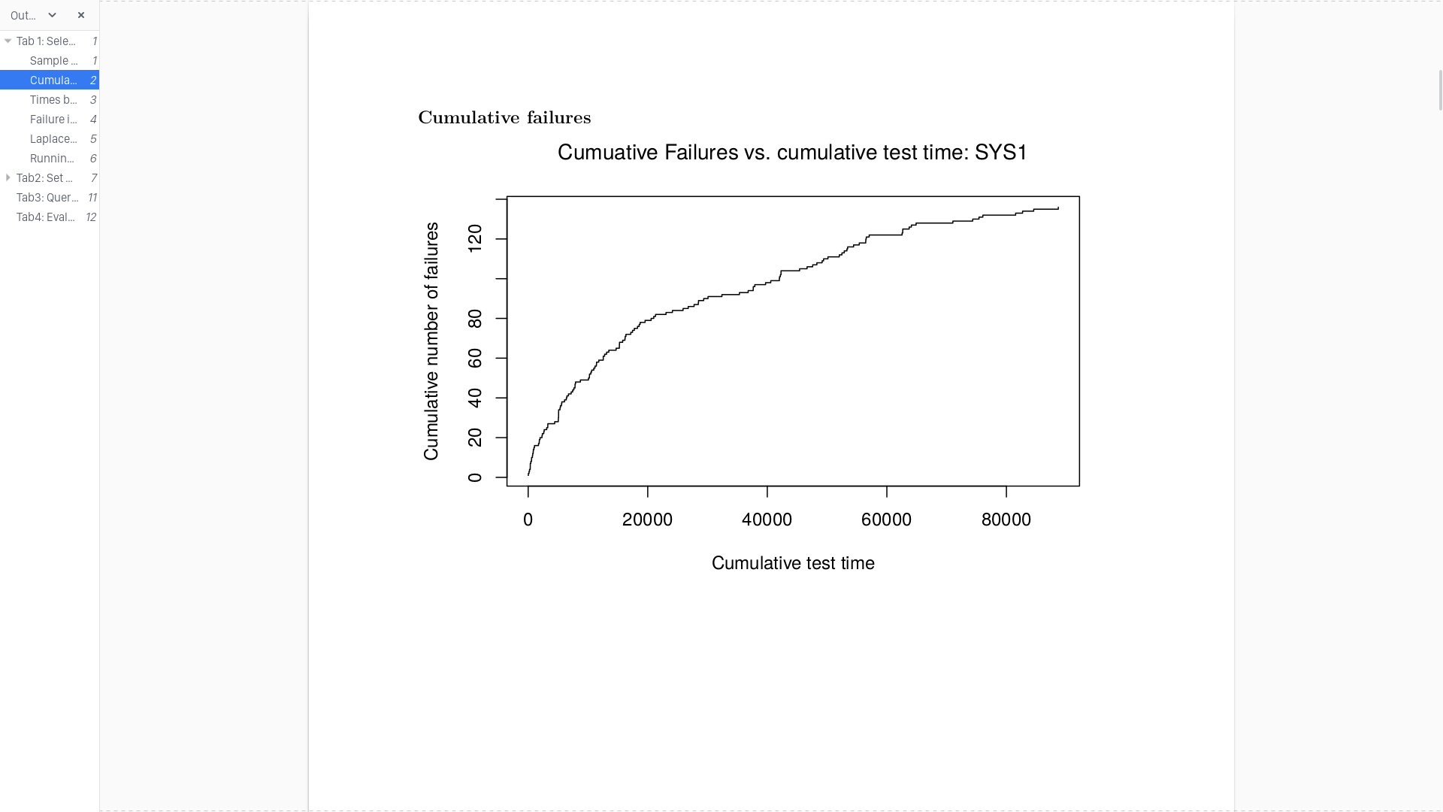

Figure _: Non-verbose Report Generation 3